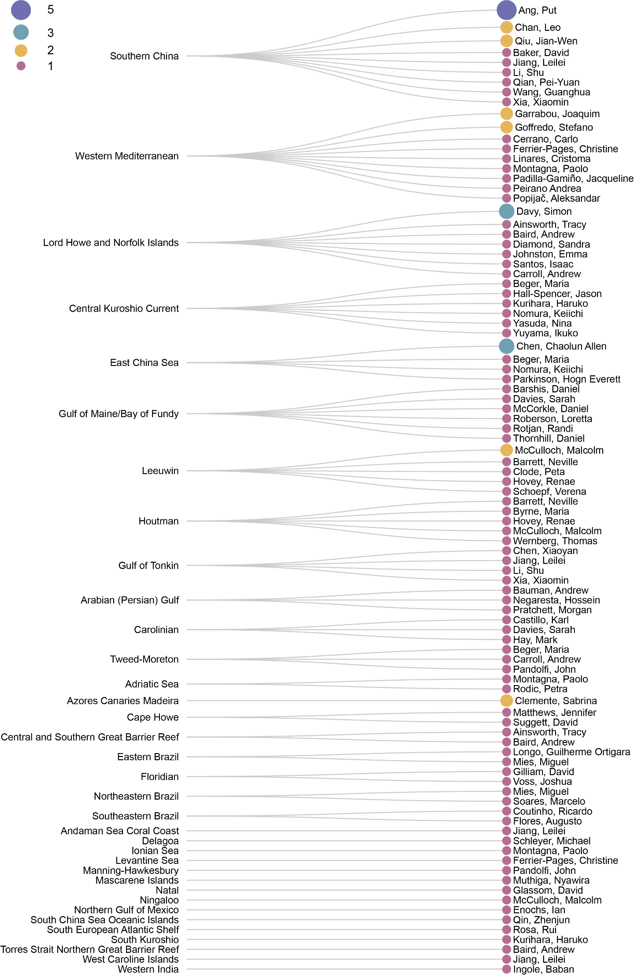

Figure 7 Linear dendrogram showing relations of last authors to ecoregions their literature focused on.